**2.1 Learning Objectives**

State the principles of DevOps

Explain the challenges in the traditional approach

Descripe how DevOps helps overcoming the challenges faced in the traditional approach

Describe the DevOps tools

Explain DevSecOps and it’s importance

**2.2 DevOps Overview**

Definition:

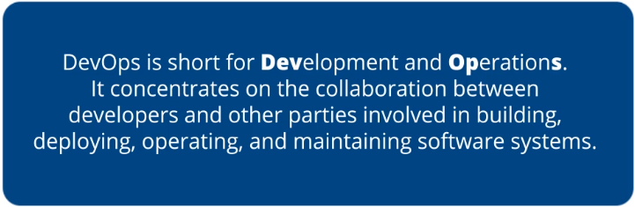

Overview of DevOps:

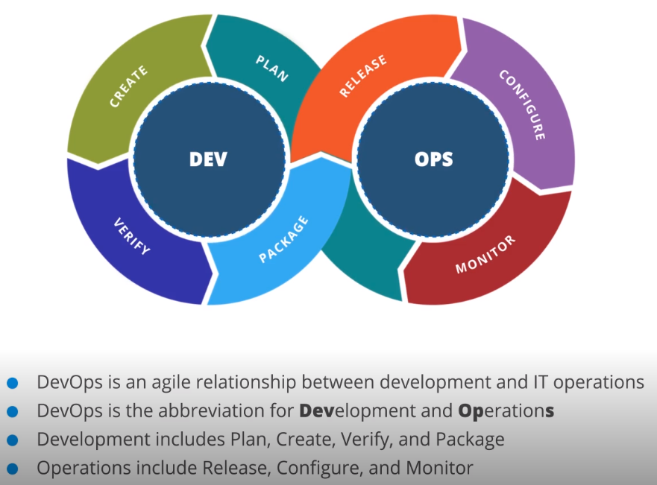

Agile Example: Scrum

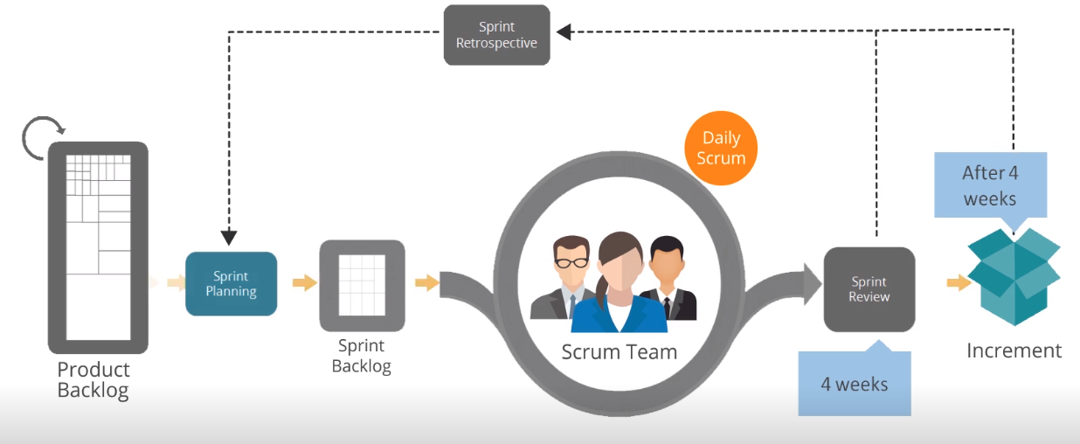

**2.3 Relationship between Agile and DevOps**

Relationship between Agile and DevOps:

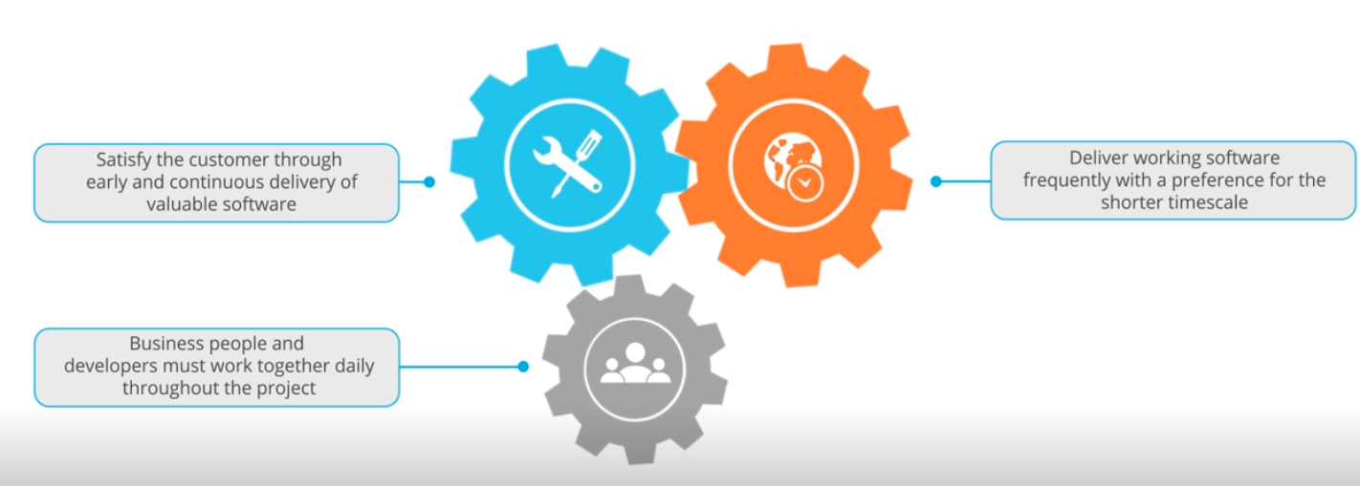

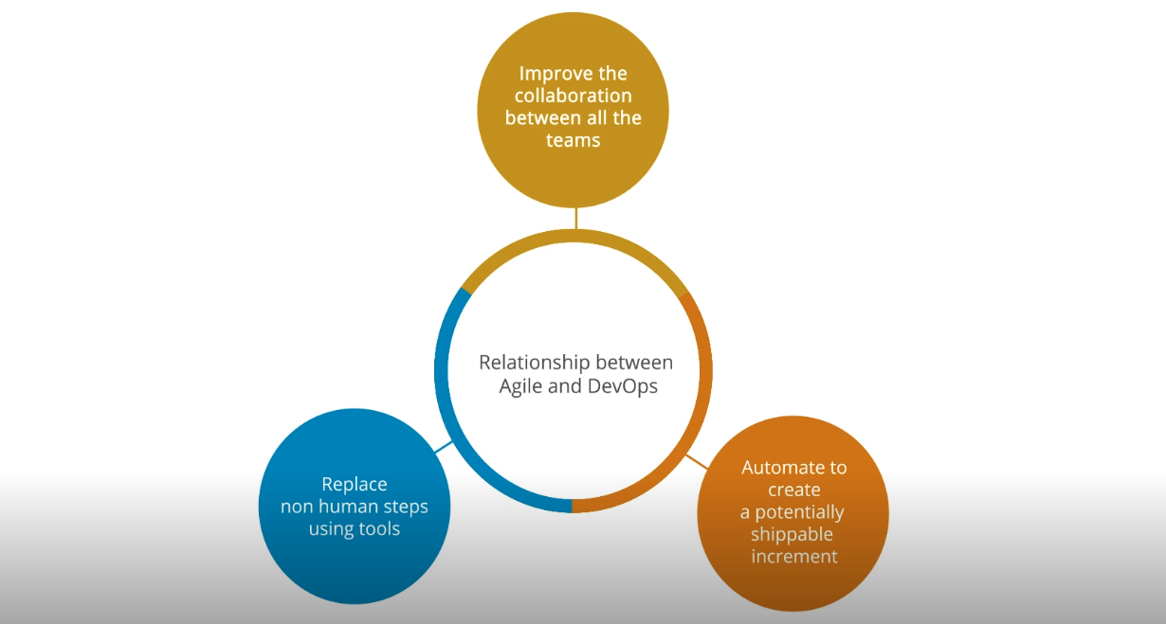

**2.4 DevOps Toolchain**

Overview:

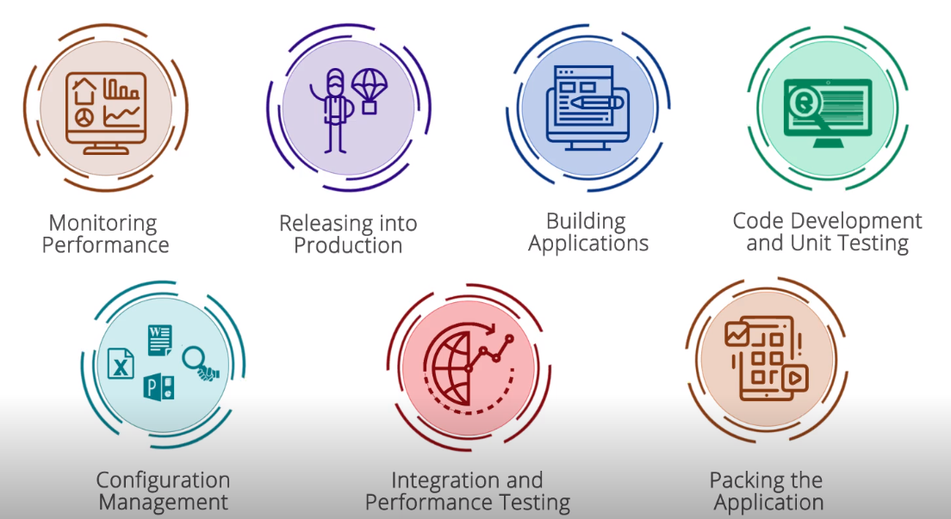

Example:

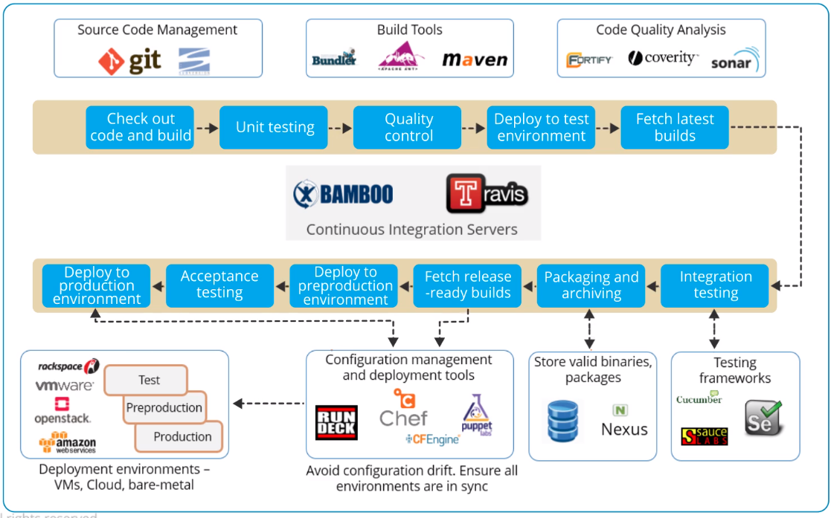

**2.5 DASA DevOps Principles**

Principles:

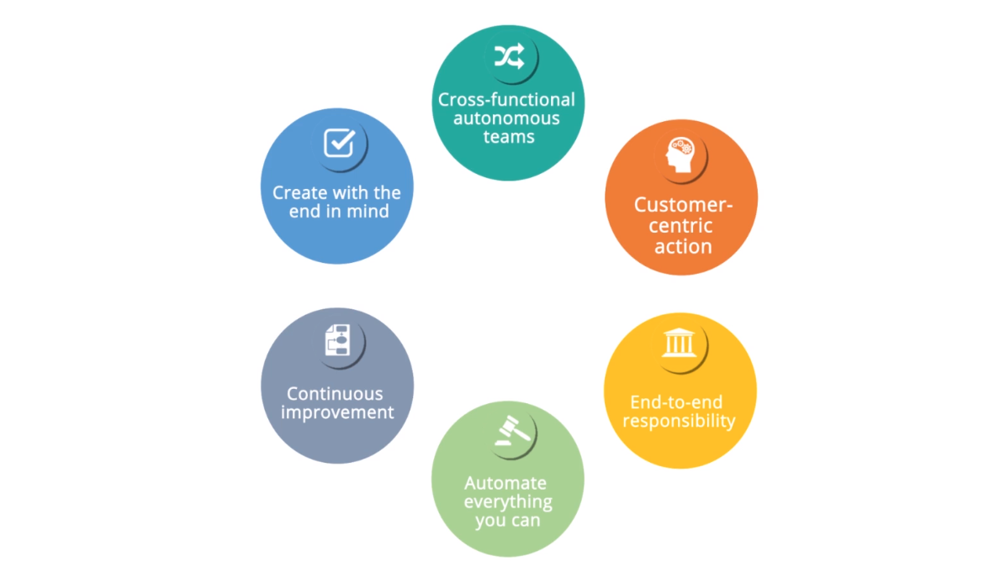

Case Study:

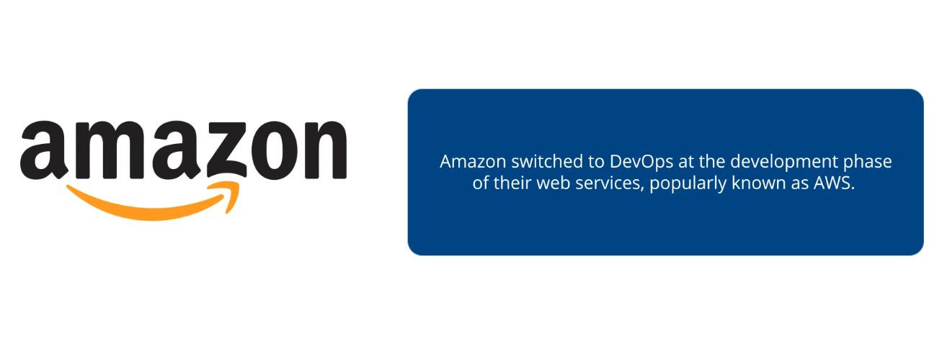

**2.6. Challenges with the tradional Approch**

Waterfall Method:

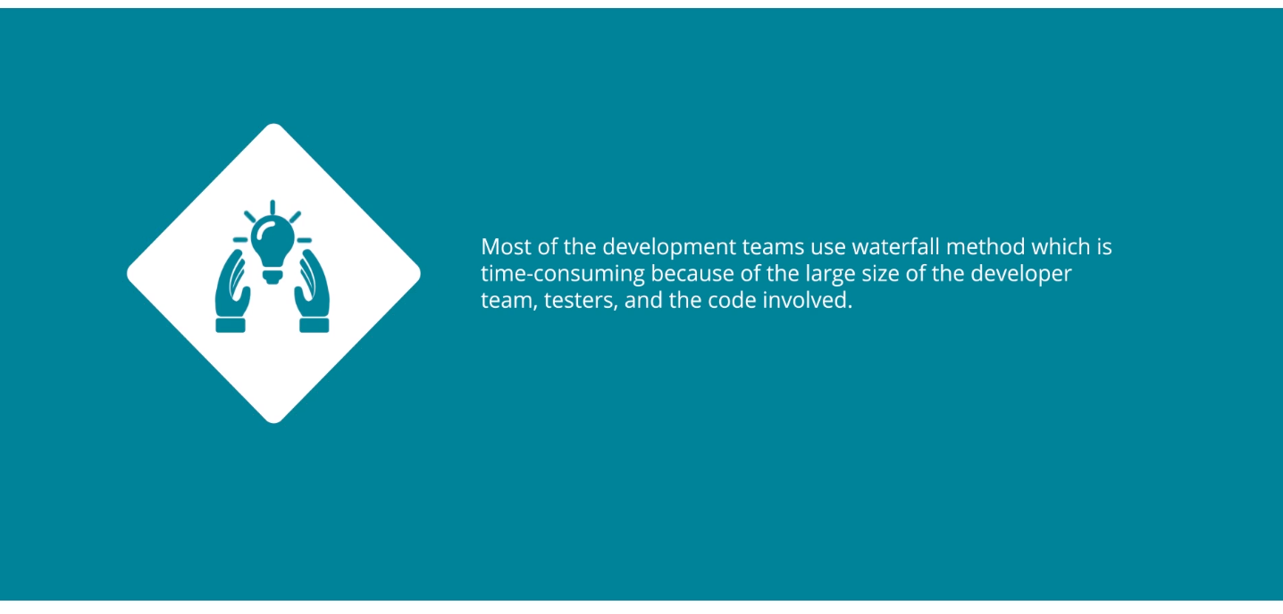

Productivity:

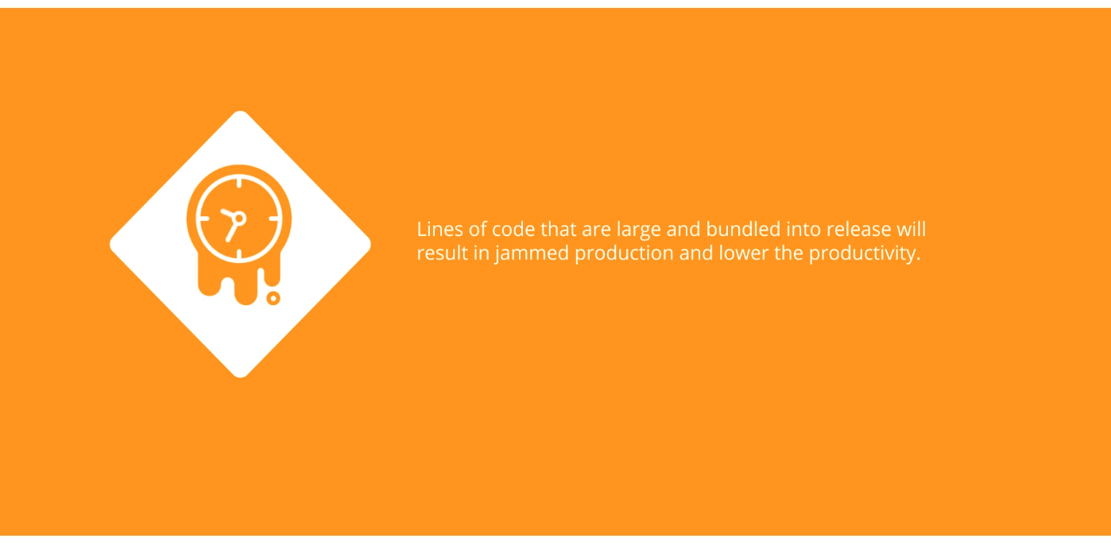

Difficult to Achieve Goal:

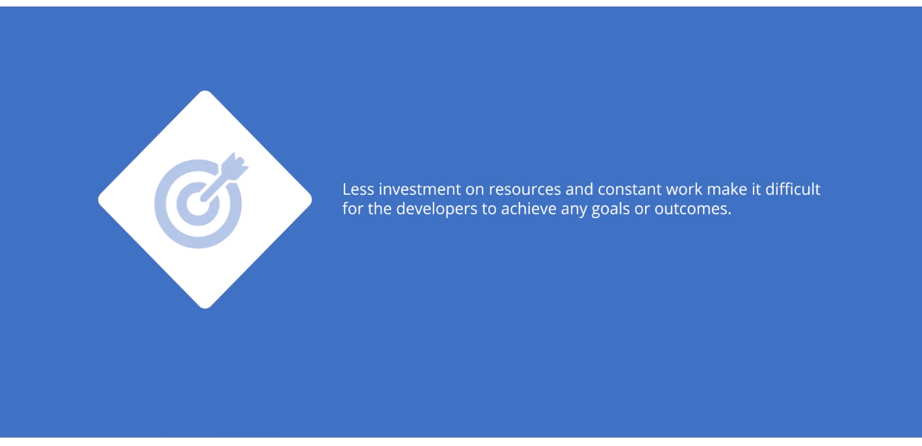

Investment in Schedule Planning System:

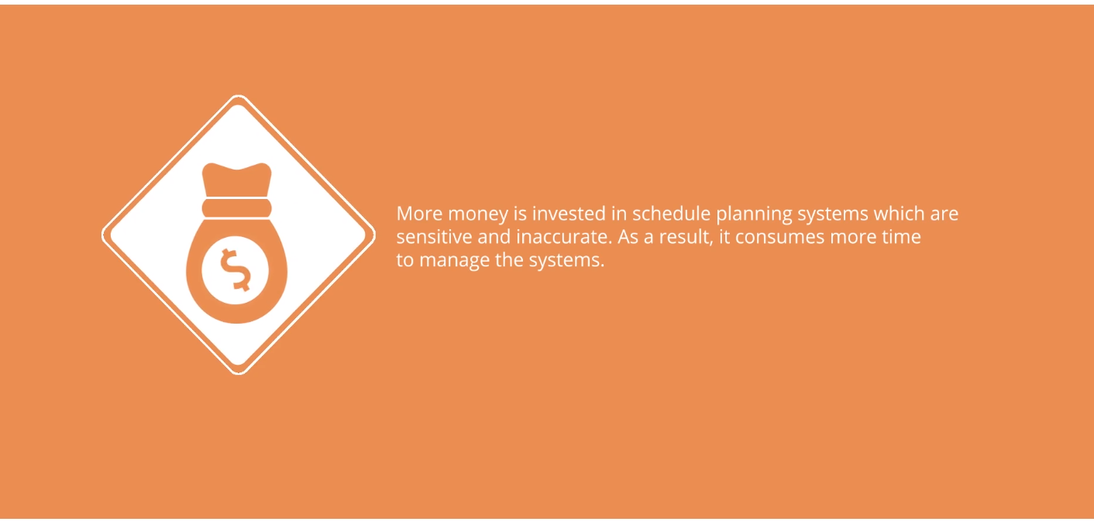

**2.7 Addressing Challenges through DevOps**

Constantly Changing Challenges:

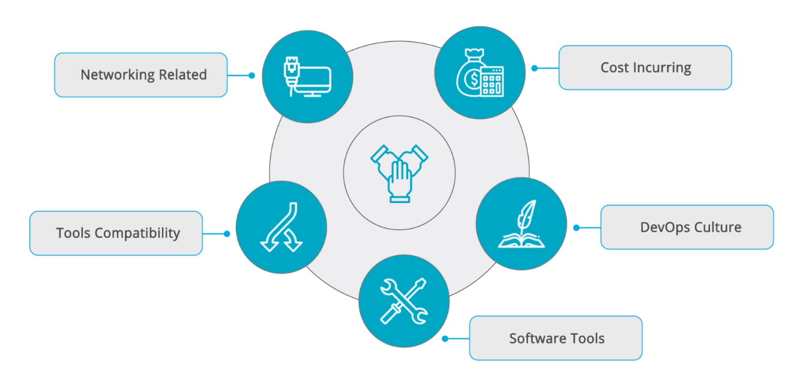

Challenges Addressed by DevOps:

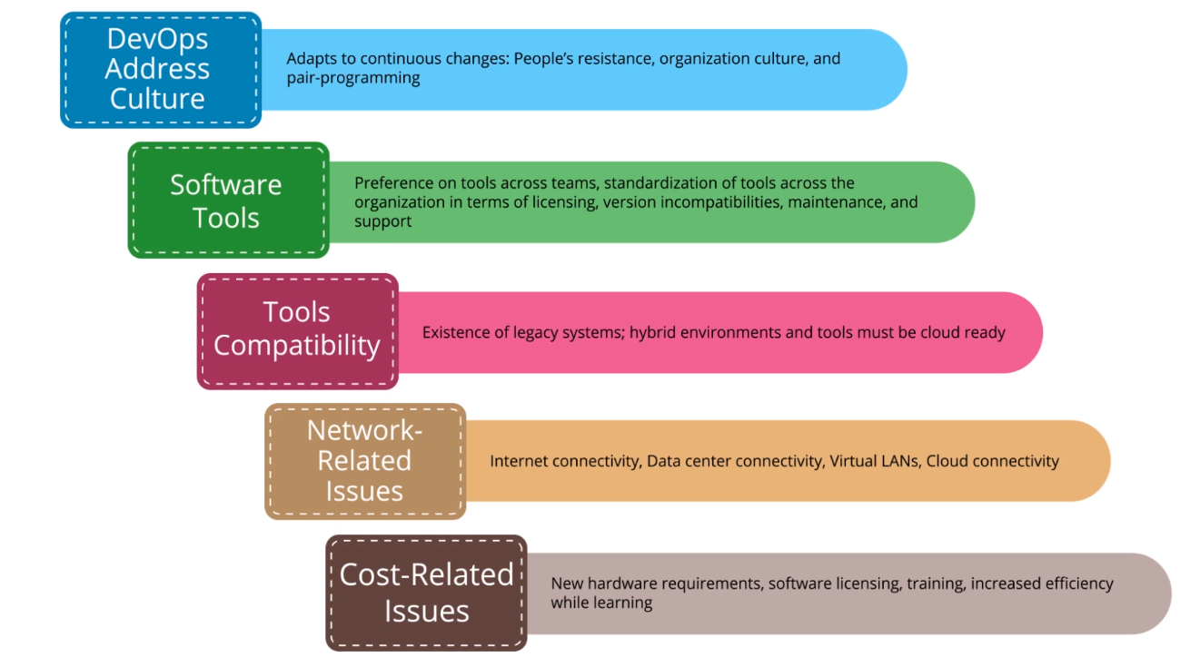

**2.8 DevOps Approch to the Challenges**

DevOps Way to Overcome Challenges:

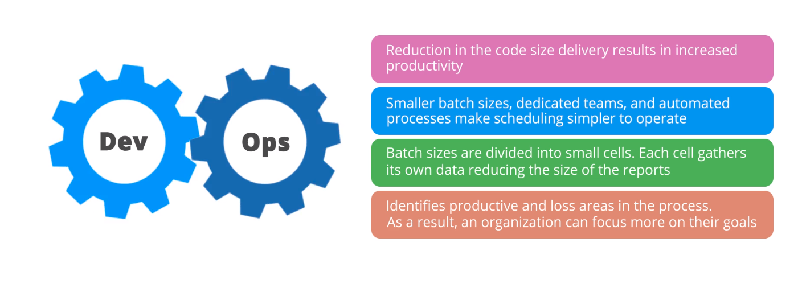

**2.9 Overview of DevOps Tools**

DevOps Tools:

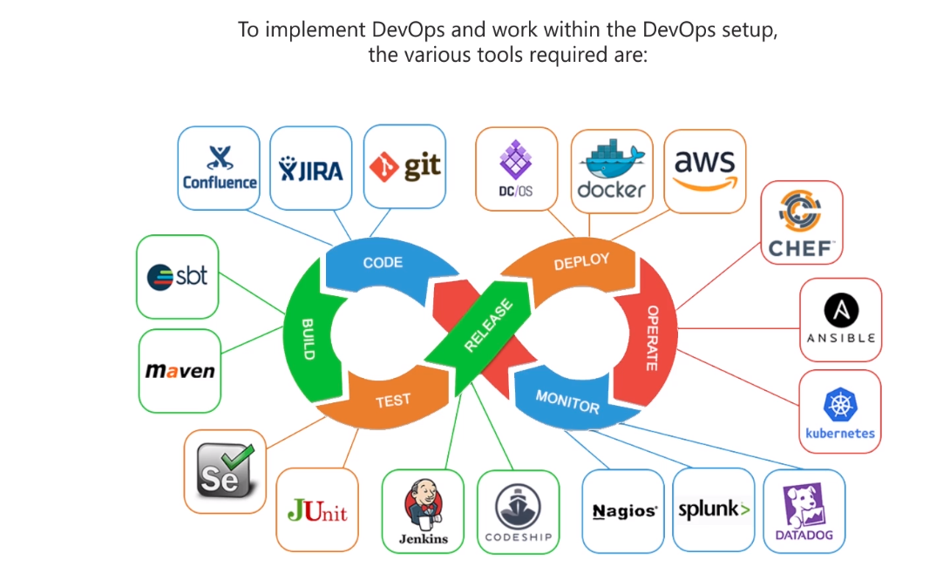

**2.10 Best Practices for DevOps**

Best Practices for DevOps:

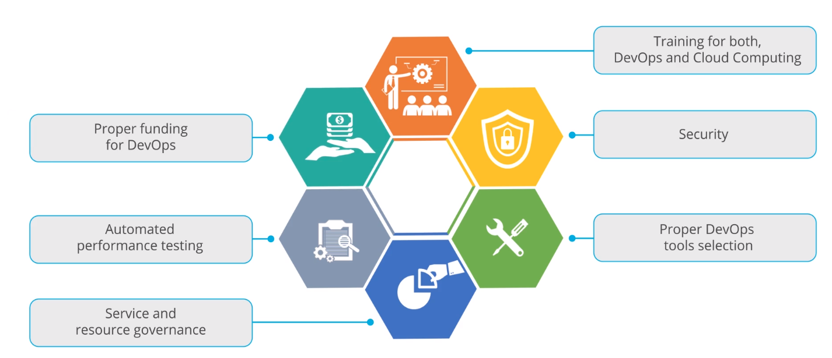

DevOps and Cloud Computing Training:

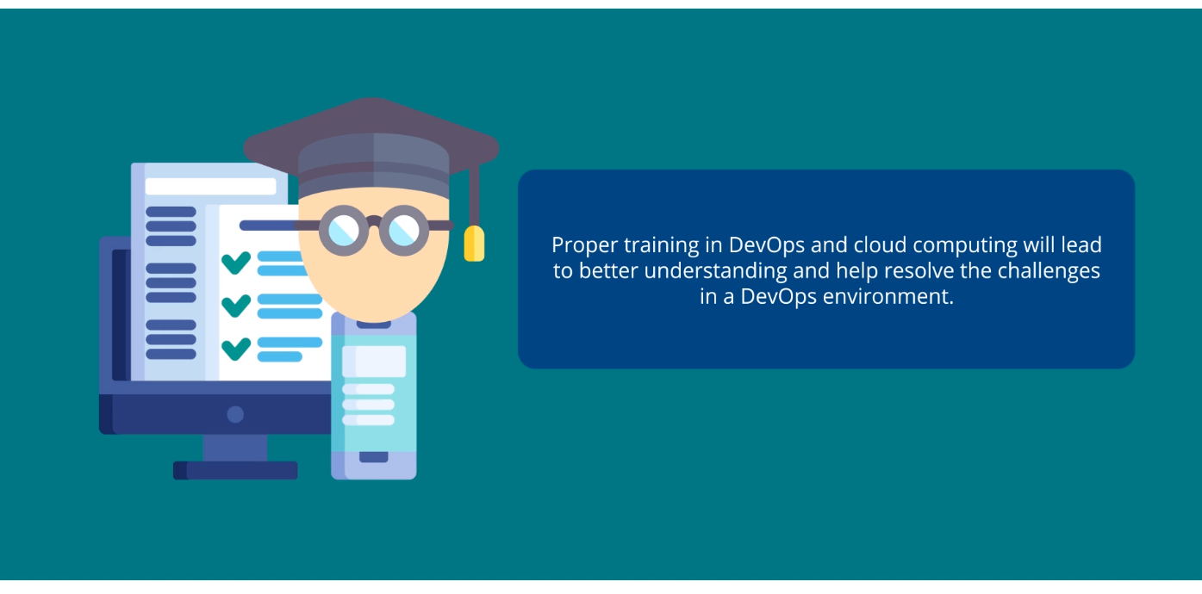

Security:

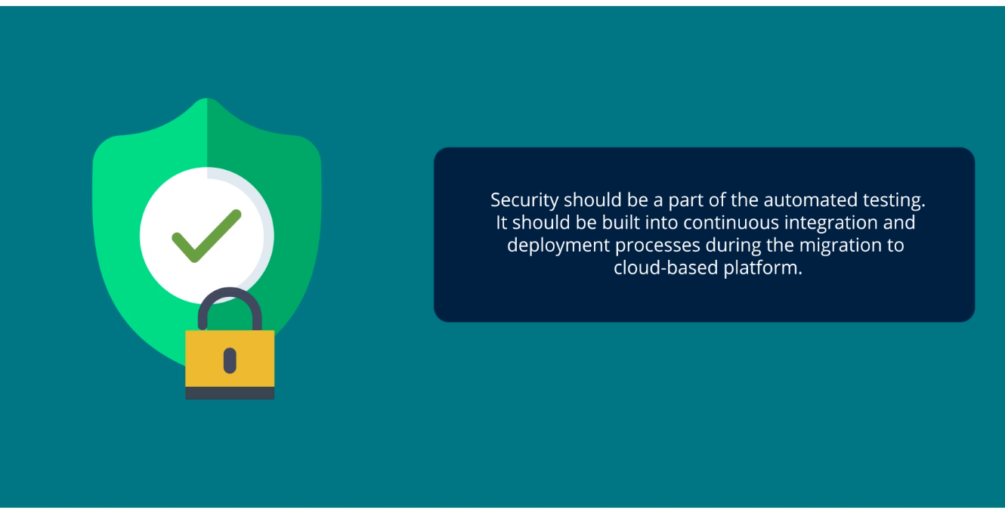

Proper DevOps Tools Selection:

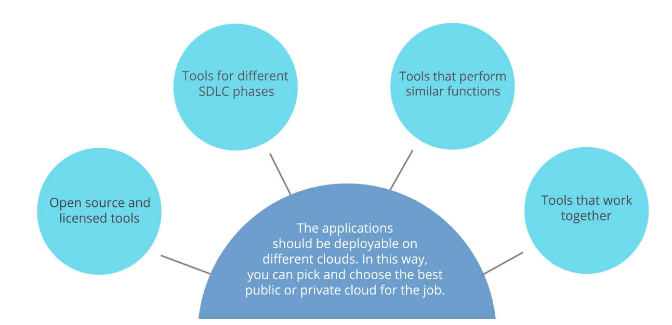

**2.11 Categories of DevOps Tools**

Requirements Tools:

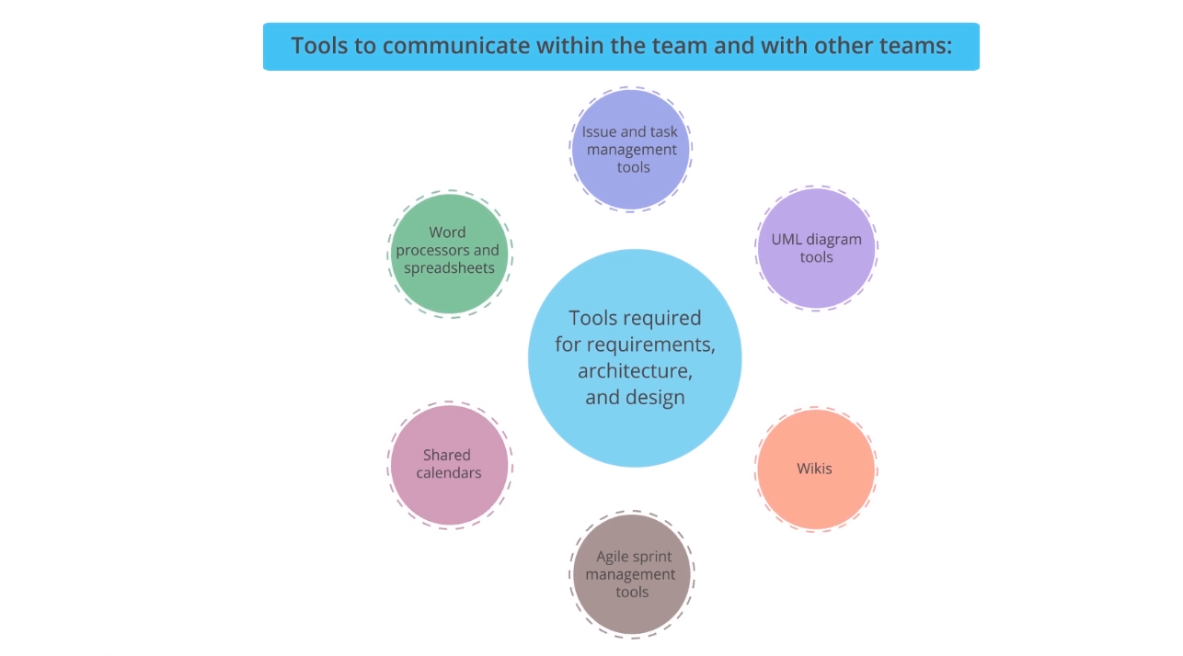

Code Development Tools:

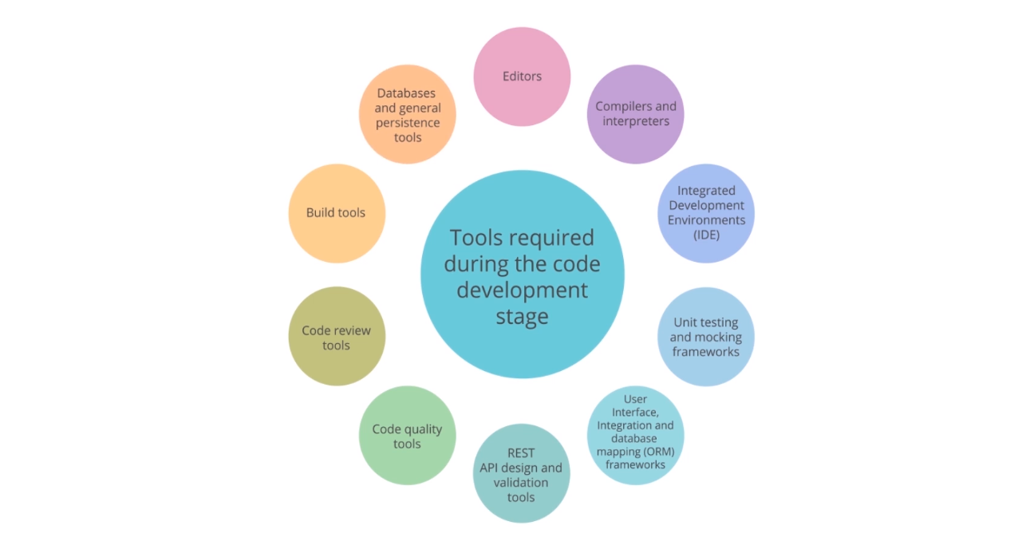

Artifact Creation Tools:

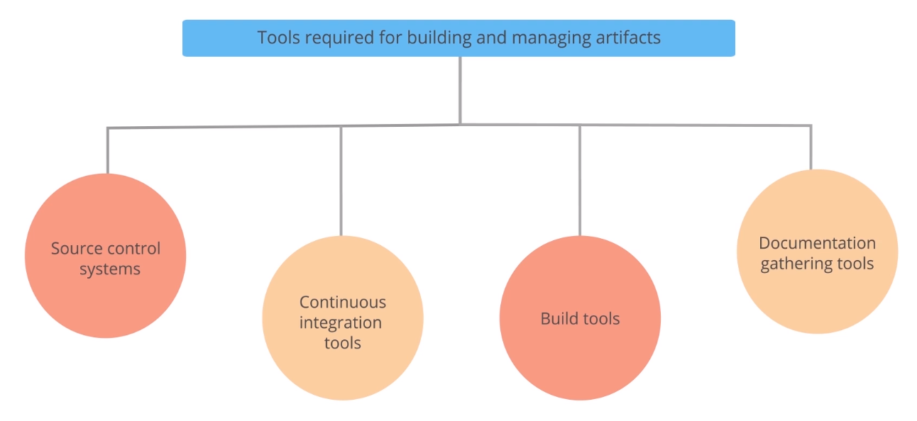

Testing Tools:

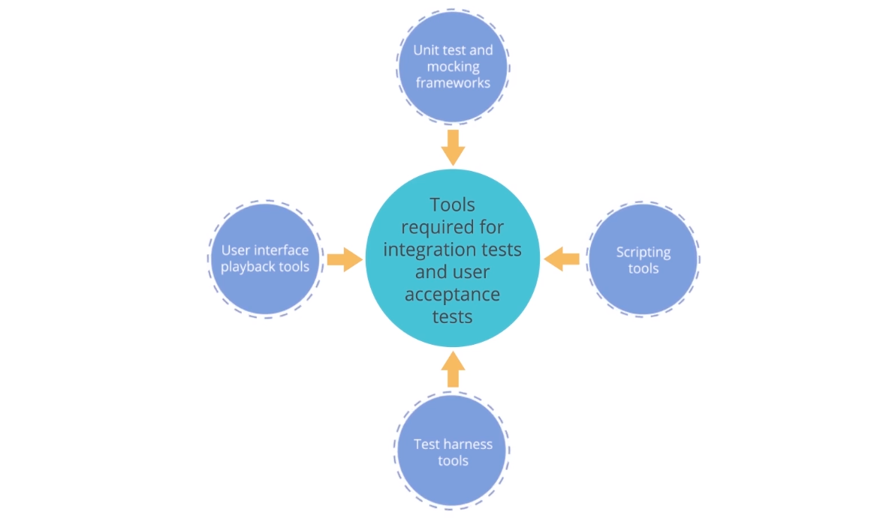

Packaging Tools:

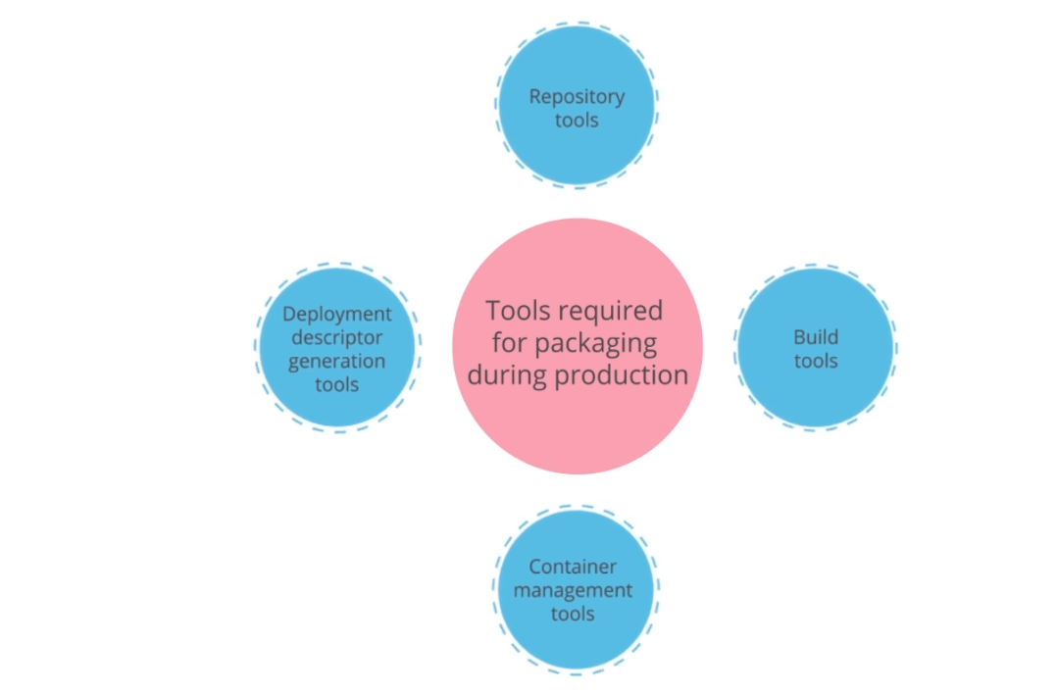

Release Management Tools:

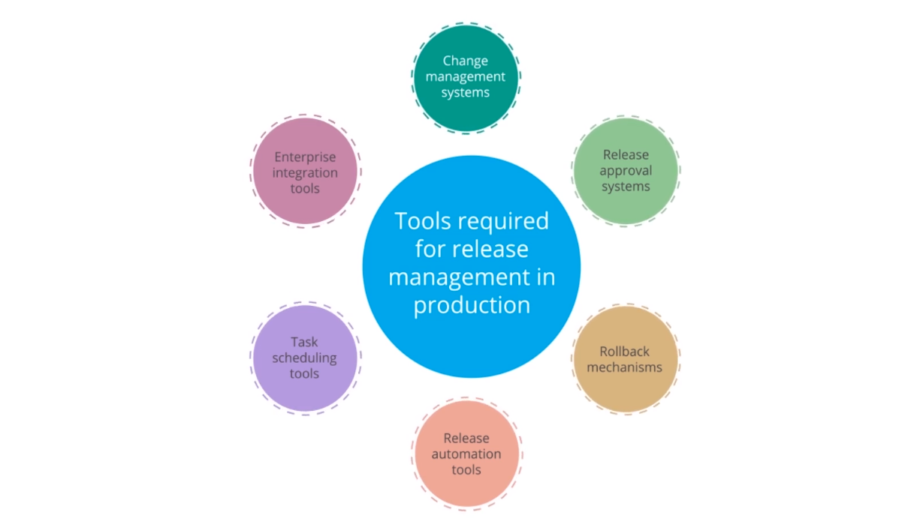

Configuration and Monitoring Tools:

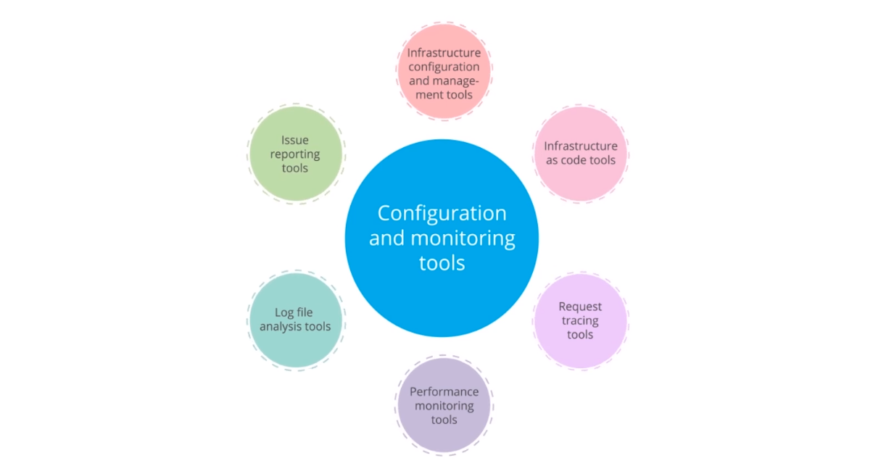

**2.12 DevSecOps and ist Manifesto**

DevSecOps:

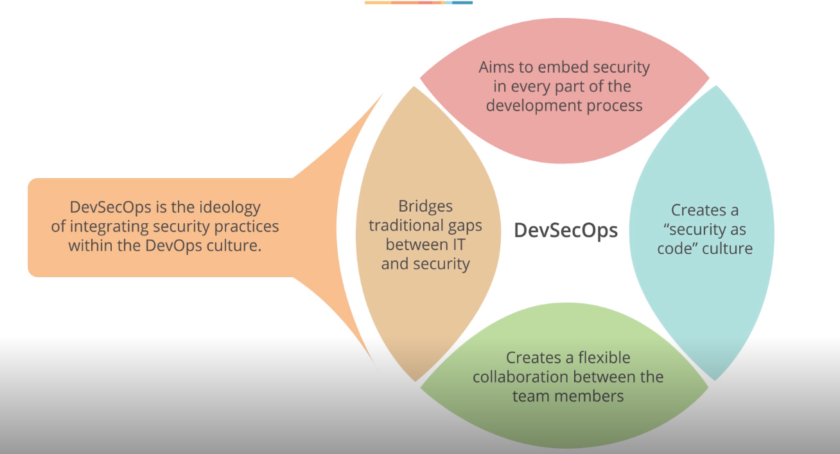

DevSecOps Manifesto:

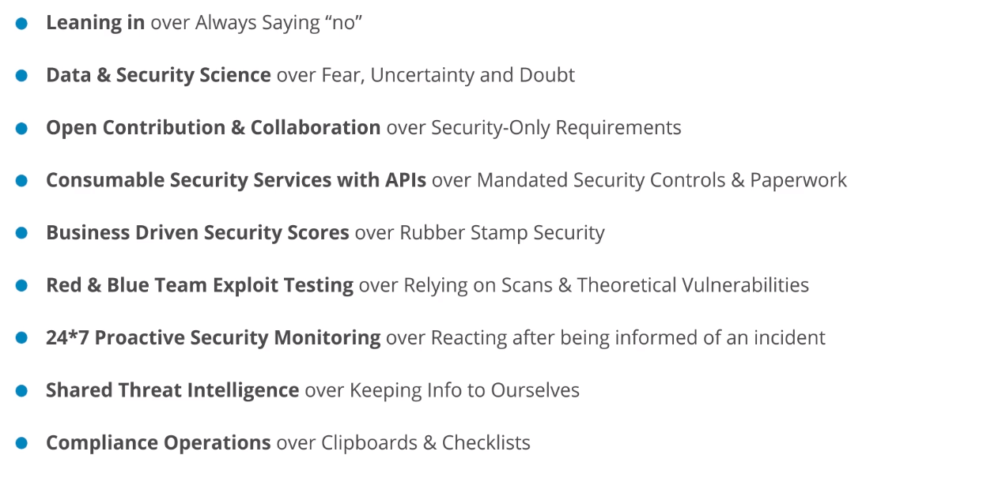

**2.13 Workflow of DevOps and DevSecOps**

Workflow of DevOps and DevSecOps:

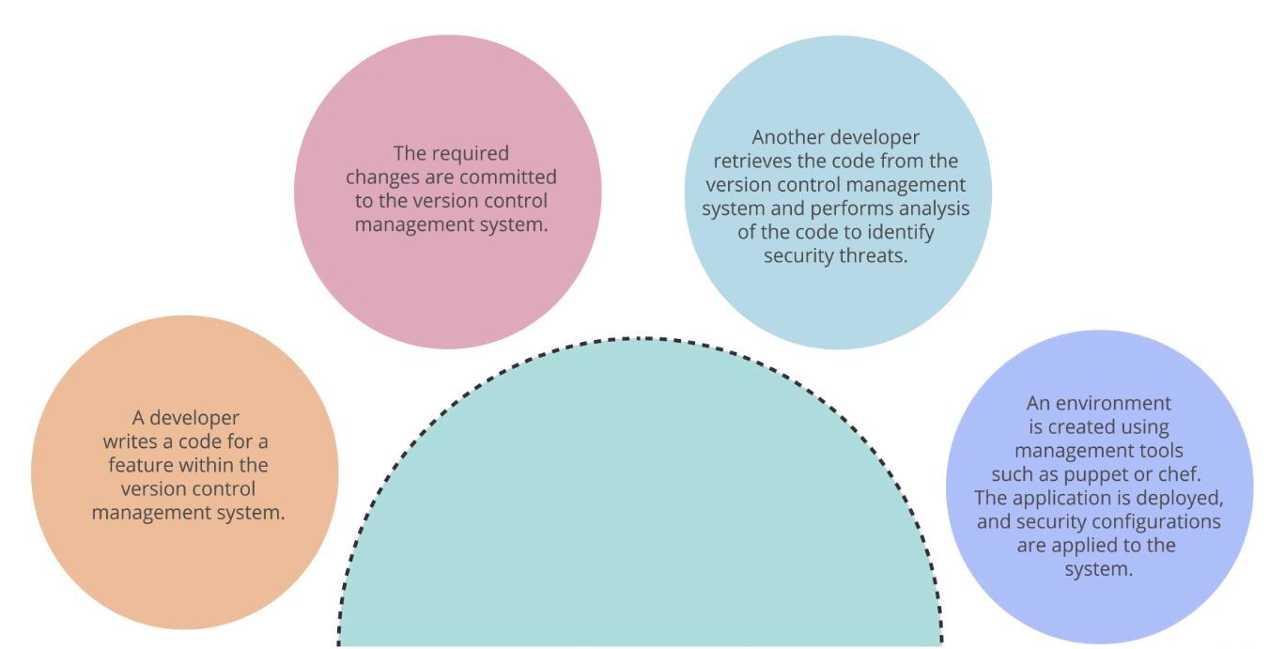

Workflow of DevOps and DevSecOps:

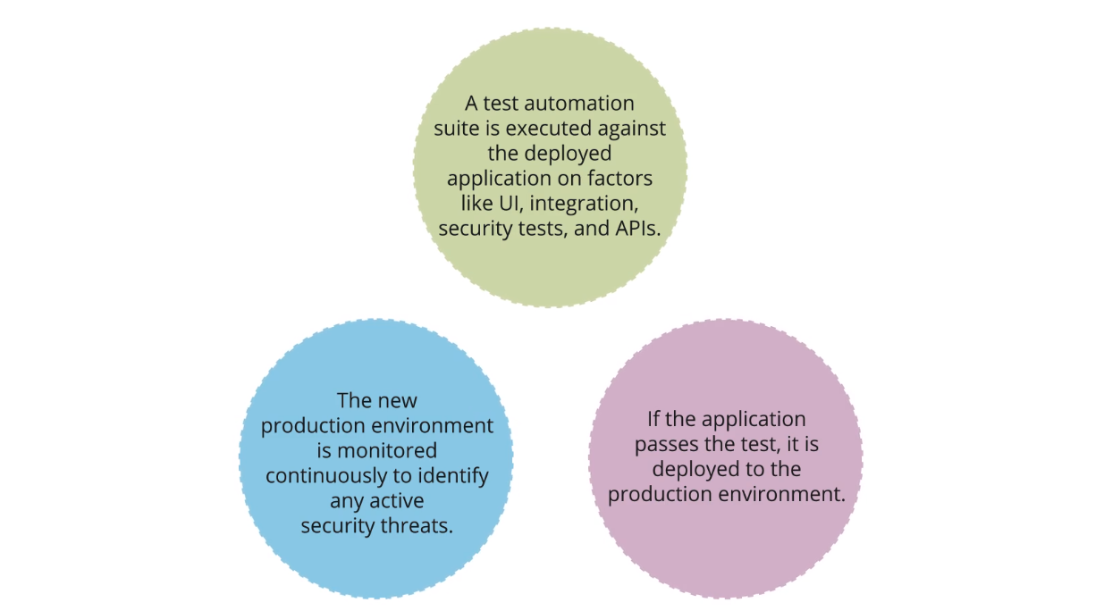

DevOps vs. DevSecOps:

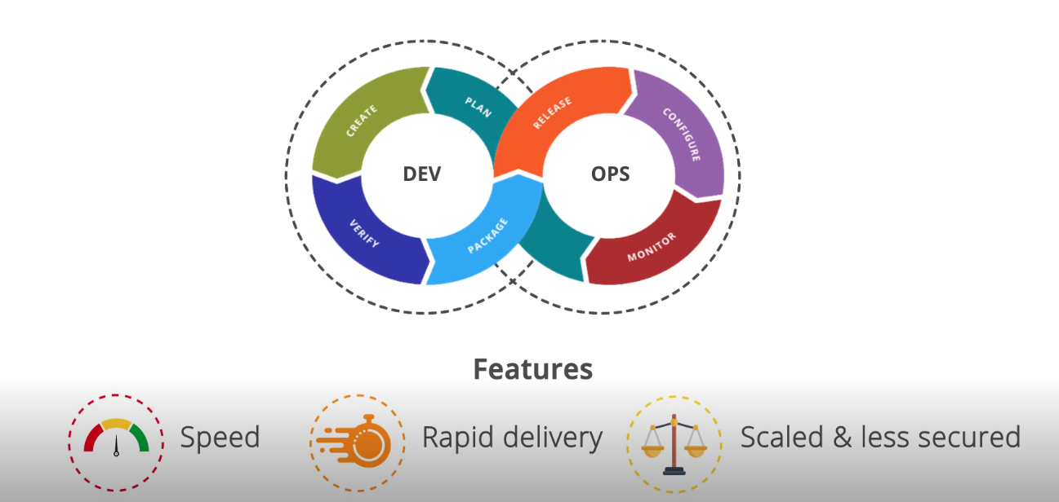

DevOps vs. DevSecOps:

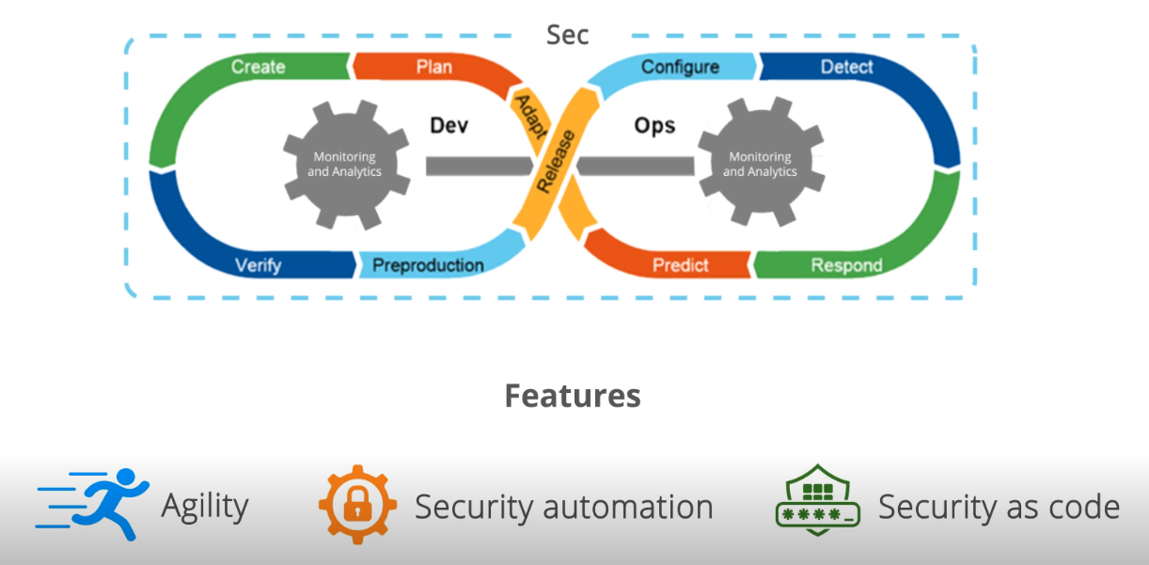

**2.14 Key Takeaways**

